**PROJECT TOPIC: Resume Classification using ML**

**Group No.: 132**

**Project Group Members:**

1. Abhishek Suman (J-4 /2115000037) **2.**  Govind (K-27/2115000416)

**3.** Dhruv Yadav (K-24 /2115000369)

**Project Supervisor:** Mr. Raushan Kumar Singh, Assistant Professor

**About the Project:**

This project focuses on helping students improve their chances of securing jobs by analyzing whether their resumes are relevant to specific job descriptions. Many students are unaware if their CV matches the required skills and qualifications demanded by employers. Using Natural Language Processing (NLP) and Machine Learning (ML) techniques, the system compares a student's resume with job postings. It highlights areas of improvement and suggests necessary updates. The goal is to make students’ resumes more targeted and competitive in the job market.

**Motivation:**

Many students struggle to understand if their resume truly matches the job roles they apply for, often missing opportunities due to irrelevant or poorly aligned CVs. This project is motivated by the need to bridge that gap and help students better tailor their resumes according to job descriptions. By using machine learning and NLP, the system provides an automated, efficient way to analyze resume relevance. It empowers students to present themselves more effectively to employers. Ultimately, the motivation is to enhance students’ career prospects by improving the quality and targeting of their CVs.

**Project Objective**:

The objective of this project is to evaluate whether a student's resume is relevant to a given job description using machine learning and NLP techniques. It aims to help students improve their chances of selection by identifying gaps and suggesting improvements. The goal is to make the resume screening process smarter, faster, and more accurate.

**Project Planning:**

The project is planned through phases like requirement gathering, dataset preparation, model training, and testing. A final system is developed to classify resumes based on their relevance to job descriptions.

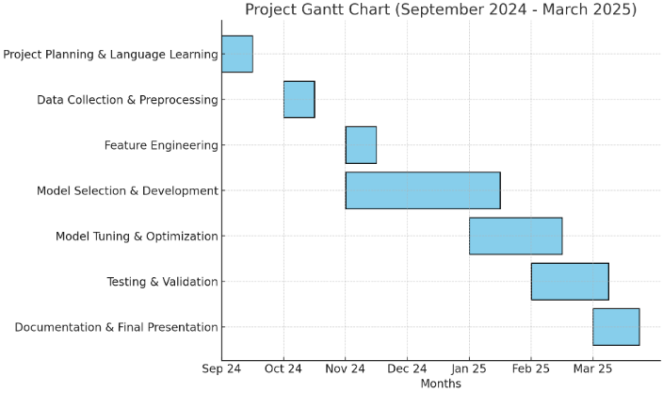

**Tools required:**

* **Hardware Requirements:**

Computer: with at least 8 GB RAM or more

100 GB storage for data processing

Internet Connection

* **Software Requirements:**

Operating System: Windows 10/11, macOS, or Linux

VS Code for code development and debugging.

Python 3

**Libraries:**

* **Pandas** for data manipulation and analysis.
* **NumPy** for numerical operations.
* **Matplotlib/Seaborn** for data visualization.
* **Scikit-learn** for machine learning models and evaluation.

**Signature of Project Supervisor: _____________________**